Set Tayo Ng Date
Use Case Specification

Submitted to:

Asst. Prof. Ma. Rowena C. Solamo
Faculty Member
Department of Computer Science
College of Engineering
University of the Philippines, Diliman

Submitted by:
Bandong, Arvin
Bariring, Edward James
Rosales, Kyle

In partial fulfillment of academic requirements
for the course
CS 191 Software Engineering I
of the
1st Semester, AY <2016-2017>
Unique Reference:
The documents are stored in the https://github.com/DarkPotatoKing/cs-191-192-repo

Document Purpose:
The purpose of this document is to describe what happens when a user tries to set a meetup schedule within the group.

Target Audience:
The target audience for this document is the user who will set a meetup schedule within the group

Revision Control

History Revision:
Revision Date | Person Responsible | Version  Number | Modification
09/26/16 | Kyle Rosales | 1.0 | Initial Document

Use-Case Name: Use-Case 2.0 Create meetup schedule

Description: The user will set a meetup schedule within the group. The user first indicates the time range for the schedule and indicate which members have to be present in the meeting. The software searches for schedules within the specified time range where each member indicated is free. The meetup schedule will then be displayed on the user's “Upcoming meetings” list.

Preconditions: The member's schedules must be already in the software's database.

Flow of Events:
Scenario Name | Description
Scenario 1 (Basic Flow)  User creates a meetup schedule | 1. User starts creating meetup schedule.  2. User inputs time range and required member for the meeting.  3. User selects a free schedule from the list of free schedules displayed.  4. User confirms the meetup schedule.  5. The meeting schedule is displayed under list of upcoming meetings.

Activity Diagram of the Flow of Events:
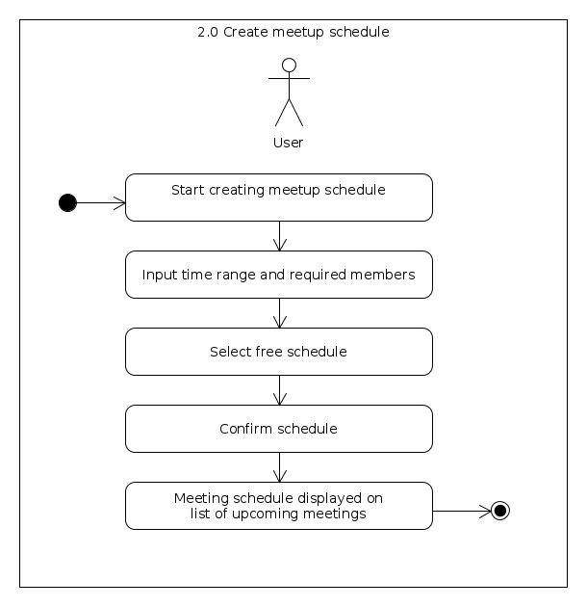

Postcondition: NONE

Relationships: NONE

Special Requirements:
NONE

